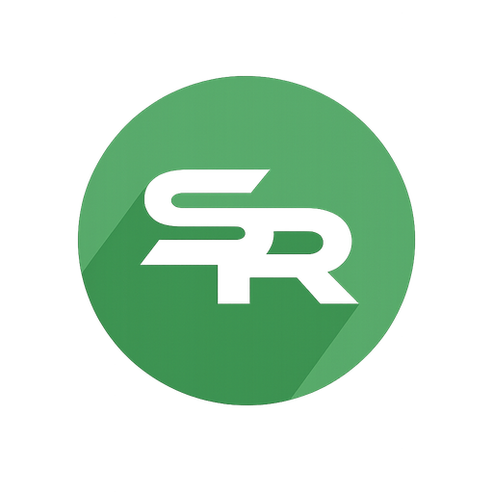

Accessibility Statement
Clarity for Education
Version 2.0
Reviewed: 11 July 2026
Current external assurance statement

Document control | Detail
Version | 2.0
Technical evidence reviewed | 11 July 2026
Publication status | Current external assurance statement
Review trigger | A material change to the public service or accessibility evidence, and at least annually

Our commitment
SENDlink LTD, trading as Student Radar, wants its public information and tools to be usable by as many people as possible. We design and test the public Student Radar website with the Web Content Accessibility Guidelines (WCAG) 2.2 Level AA as our target.
This is a statement of intent and current evidence, not a claim that every page, file or authenticated product workflow has been independently certified as fully conformant.

Scope
This statement covers:
- www.studentradar.com, including public information about Core, SEND, Lead, Safeguard, Connect, Assess, Health and Teach;
- the pricing information that includes the Office package while its public capability page is still being prepared;
- public buyer tools, including Compare, Pricing and Pathfinder;
- public resources and the Echo and Sensory Profiler tools; and
- the public procurement library and its browser-rendered pages.
The authenticated Student Radar platform contains additional, role-restricted workflows. Accessibility evidence for a selected platform capability can be discussed during procurement. This statement does not extend public-site test results to an authenticated workflow that was not included in the same review.

Measures implemented on the public website
The current public-site implementation includes:
- an English language declaration and one named main landmark on each generated page;
- a visible-on-focus link that moves keyboard focus past the repeated header to the main content;
- semantic links, buttons, headings, form labels and status announcements;
- keyboard-operable navigation and a shared dialog pattern that closes with Escape, keeps focus within the dialog while open and returns focus to the trigger;
- form errors connected to their fields using programmatic descriptions and live status messages;
- a solid, offset focus indicator designed to remain visible on light and dark surfaces;
- text and primary action colours selected to meet the relevant WCAG contrast targets;
- reduced-motion behaviour that disables smooth scrolling and shortens animation when the user requests reduced motion; and
- responsive containment checks at 320px, 390px, landscape mobile and a 200% zoom-equivalent viewport on representative routes.
Wide comparison matrices and legacy resource tables may scroll within their own labelled region on small screens. They should not widen the whole page.

Testing and evidence
The public-site delivery pipeline includes:
- automated checks for one main landmark across sitemap routes;
- automated accessibility scans on representative templates using WCAG 2.0, 2.1 and 2.2 rules, with serious and critical findings treated as blocking failures;
- browser tests for keyboard navigation, focus handling, dialogs, form semantics and responsive containment; and
- a three-run mobile Lighthouse budget for the homepage with a median accessibility score threshold of 98.
Automated testing finds many common failures but cannot prove complete WCAG conformance. Content, assistive-technology behaviour and complex journeys still need human review.

Known limits
- The current evidence is representative rather than an independent audit of every public route and every assistive-technology combination.
- Procurement DOCX and PDF files have their own document-accessibility requirements. A browser page passing automated checks does not make an attached office document or PDF accessible automatically.
- Very wide data sets may require horizontal scrolling within their content region at narrow widths.
- Third-party operating-system, browser or provider behaviour may affect the experience outside Student Radar's direct control.
- Authenticated platform workflows must be assessed against the version and capability being procured; this public statement does not certify them by implication.
We do not describe the service as fully conformant until the relevant scope and evidence support that conclusion.

Reporting a problem or requesting an alternative format
If you encounter an accessibility problem, need information in another format, or want accessibility evidence for a procurement review, contact support@studentradar.com.
Please identify the page or document, the task you were trying to complete, the device or assistive technology involved, and the format or adjustment that would help. Do not include pupil or confidential case information in an accessibility report.
We will assess the issue, confirm the affected scope and provide an update or reasonable alternative where practicable. Material findings are added to the accessibility backlog and reviewed as part of the normal delivery process.

Status of this statement
This statement is an informational assurance document. It does not vary an executed agreement, create an accessibility certification, or replace a capability-specific assessment requested by a school or trust.

